Content

|  |  |  |
| --- | --- | --- |
| **Sl No.** | **Description** | **Page No.** |
| 1 | Abstract | 5 |
| 2 | Introduction and Objectives of the Project | 5 |
| 3 | Project Category (RDBMS/OOPS/Networking/Multimedia/ArtificialIntelligence/Expert Systems etc.) | 5 |
| 4 | Tools/Platform, Hardware and Software Requirement specifications | 5-6 |
| 5 | Goals of Implementation | 6 |
| 6 | SDLC Process Applied | 7-8 |
| 7 | Data Model | 8 |
| 8 | Functional Requirements (Use Case Diagram) | 9-12 |
| 9 | Non-functional Requirements | 12-14 |
| 10 | Feasibility Study | 14-16 |
| 11 | Project Planning | 16 |
| 12 | Project Scheduling | 17 |
| 13 | Software Engineering Paradigm applied | 17-19 |
| 14 | Database design | 20-22 |
| 15 | User Interface Design | 22-32 |
| 16 | Coding | 32-77 |
| 17 | Testing | 78-82 |
| 18 | System Security measures | 82 |
| 19 | Database/Data security | 82 |
| 20 | Creation of User profiles and access rights | 82 |
| 21 | Cost Estimation of the Project along with Cost Estimation Model | 82-83 |
| 22 | Future scope and further enhancement of the Project | 83 |
| 23 | Bibliography | 83-84 |
| 24 | Appendix | 84 |

1. Abstract :-

This project aims to develop a web application is for ONLINE CLASSIFIED ADS. This is an online website where multiple users can view and information of the posted products.This project, once implemented, will enable people to get access to an online selling store. The main object of this application is to make it interactive and its ease of use.It would make selling things much easier than earlier.

2.**Introduction** and Objectives of the Project :-

Online Clasisfied Ads System is the system for manage the Online Selling Market. The main point of developing this system is to help Selling Market administrator manage the online Selling Market and help customer for online ordering and reserve table. The project is developing because; many seller have a lot difficult to sell . By using manual customer selling is difficult to find the correct customer information and maybe loss the customer information. So, online restaurant management system will develop to help the restaurant administrator to manage restaurant management and for customer make their online ordering and reservation table. Other than that, this project is to upgrade the manual system and make the business easily to access and systematic.

3.Project Category :-

Web Application.

4.Tools/Platform,Hardware & Software Requirement specifications :-

* **Tools :-**

pycharm

Diatool

* **Platform :-**

Microsoft Windows 7/8/10

* **Hardware Requirement Specification**

|  |  |  |  |
| --- | --- | --- | --- |
| **Client Machine** | | **Server Machine** | |
| **HDD** | 200 MB | **HDD** | 320 GB |
| **Processor** | Pentium 4 or newer processor that supports SSE2 | **Processor** | Dual Core or newer processor |
| **Memory** | 512 MB | **Memory** | 2 GB |

* **Software Requirement Specification**

|  |  |  |  |
| --- | --- | --- | --- |
| **Client Machine** | | **Server Machine** | |
| **Browser** | Any standard browser with JavaScript interpreter | **Software** | IIS |
| **Client side markup / scripting languages** | HTML, JavaScript | **Database Management System Software** | MySQL |
|  |  | **Specification** | MySQL-4.1 |

5.Goals of Implementation :-

The implementation aims at seamless document sharing across the institution.

6.SDLC

ProcessAppApplied :-



Often, a customer defines a set of general objectives for software but does not identify detailed input, processing, or output requirements. In other cases, the developer may be unsure of the efficiency of an algorithm, the adaptability of an operating system, or the form that human/machine interaction should take. In these, and many other situations, a prototyping paradigm may offer the best approach.

The prototyping paradigm begins with **requirements gathering**. Developer and customer meet and define the overall objectives for the software, identify whatever requirements are known, and outline areas where further definition is mandatory. A **"quick design"** then occurs. The quick design focuses on a representation of those aspects of the software that will be visible to the customer/user (e.g., input approaches and output formats). The quick design leads to the construction of a prototype. The prototype is evaluated by the customer/user and used to refine requirements for the software to be developed. Iteration occurs as the prototype is tuned to satisfy the needs of the customer, while at the same time enabling the developer to better understandwhat needs to be done.

Ideally, the prototype serves as a mechanism for identifying software requirements. If a working prototype is built, the developer attempts to use existing program fragments or applies tools (e.g., report generators, window managers) that enable working programs to be generated quickly.

7.Data Model :-

**ER-DIAGEAM:-** 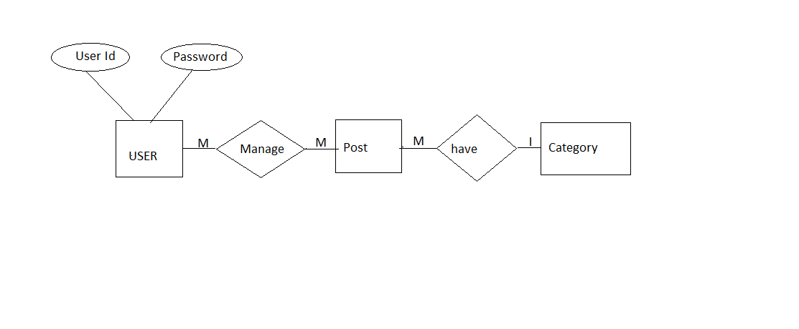

8. Functional Requirements :-

Functional Requirements are those that refer to the functionality of the system, i.e., what services it will provide to the user. Nonfunctional (supplementary) requirements pertain to other information needed to produce the correct system and are detailed separately.

* **Use-Case-Diagram:-** 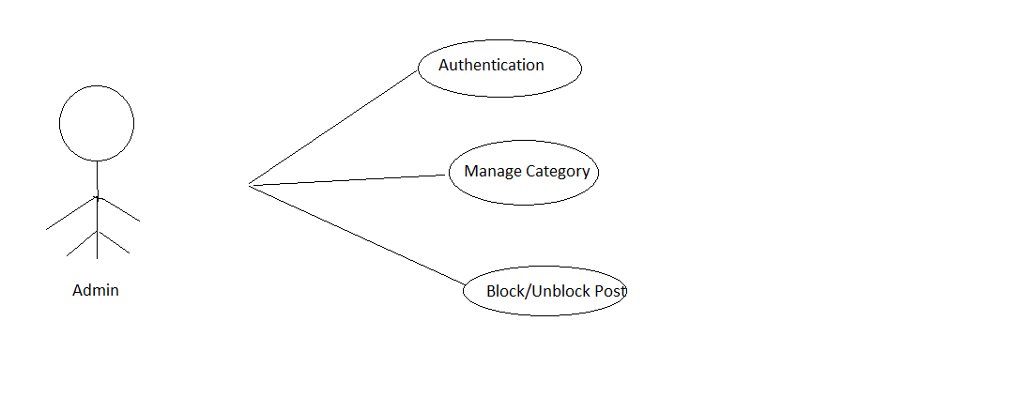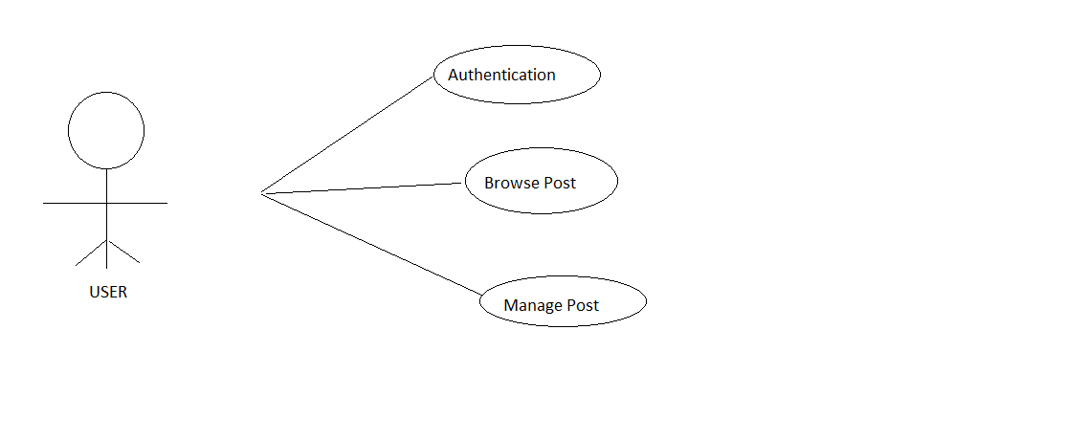
* **Use Case Descriptions :-**

|  |  |
| --- | --- |
| **Use Case Name:** | Authentication |
| **Priority** | Essential |
| **Trigger** | Menu selection |
| **Precondition** | User is connected to the Internet and on the restaurant home page |
| **Basic Path** | 1. User enters username and password. 2. The username and password is matched with the record in the database. 3. If the authentication parameters are correct the user is directed to the user’s main page, otherwise an error message is displayed. |
| **Alternate Path** | NA |
| **Post Condition** | The user is on the User Home Page |
| **Exception Path** | If there is a connection failure the server returns to the wait state |
| **Use Case Name:** | Authentication |
| **Priority** | Essential |
| **Trigger** | Menu selection |
| **Precondition** | User is connected to the Internet and on the main page |
| **Basic Path** | 1. User enters values for all the fields. 2. User clicks on the submit button. 3. The server side program processes the request and returns the User registration number. |
| **Alternate Path** | NA |
| **Post Condition** | The User registers himself/herself with the Book Store cell |
| **Exception Path** | If there is a connection failure the server returns to the wait state |

|  |  |
| --- | --- |
| **Use Case Name:** | Browse Post |
| **Priority** | Essential |
| **Trigger** | Menu selection |
| **Precondition** | Admin is connected to the Internet and on the admin’s main page |
| **Basic Path** | 1. User browses the post 2. User searches the post |
| **Alternate Path** | NA |
| **Post Condition** | The admin can see all foods. |
| **Exception Path** | If there is a connection failure the server returns to the wait state |
| **Use Case Name:** | Add Food Details |
| **Priority** | Essential |
| **Trigger** | Menu selection |
| **Precondition** | Admin is connected to the Internet and on the admin’s main page |
| **Basic Path** | 1. The Admin gives food Details 2. The details of the foods is available when a link from the link is clicked |
| **Alternate Path** | NA |
| **Post Condition** | The admin searches by food name |
| **Exception Path** | If there is a connection failure the server returns to the wait state |

|  |  |
| --- | --- |
| **Use Case Name:** | Block/Unblock post |
| **Priority** | Essential |
| **Trigger** | Menu selection |
| **Precondition** | User is connected to the Internet and on the main page |
| **Basic Path** | 1. Admin blocks the post by clicking the |
| **Alternate Path** | NA |
| **Post Condition** | The Admin update his/her foods with the Food Store cell |
| **Exception Path** | If there is a connection failure the server returns to the wait state |

9. Non Functional Requirements :-

In addition to the obvious features and functions that you will provide in your system, there are other requirements that don't actually DO anything, but are important characteristics nevertheless. These are called "non-functional requirements" or sometimes "Quality Attributes." For example, attributes such as performance, security, usability, compatibility. Aren’t a "feature" of the system, but are a required characteristic. You can't write a specific line of code to implement them; rather they are "emergent" properties that arise from the entire solution. The specification needs to describe any such attributes the customer requires. You must decide the kind of requirements that apply to your project and include those that are appropriate.

Each requirement is simply stated in English. Each requirement must be objective and quantifiable; there must be some measurable way to assess whether the requirement has been met.

Often deciding on quality attributes requires making tradeoffs, e.g., between performance and maintainability. In the APPENDIX you must include an engineering analysis of any significant decisions regarding tradeoffs between competing attributes.

Here are some examples of non-functional requirements:

* **Performance requirements :-**

Requirements about resources required, response time, transaction rates, throughput, benchmark specifications or anything else having to do with performance.For better performance the application will restrict the document size to 5 MB.

* **Operating constraints:-**

List any run-time constraints. This could include system resources, people, and needed software.

The application must run without any manual intervention.

* **Platform constraints:-**

Discuss the target platform. Be as specific or general as the user requires. If the user doesn't care, there are still platform constraints.

Since the application will be developed in PHP it is platform independent.

* **Accuracy and Precision:-**

Requirements about the accuracy and precision of the data. (Do you know the difference?) Beware of 100% requirements; they often cost too much.

* **Modifiability:-**

Requirements about the effort required to make changes in the software. Often, the measurement is personnel effort (person- months).

Minimal

* **Portability:-**

The effort required to move the software to a different target platform. The measurement is most commonly person-months or % of modules that need changing.

Minimal

* **Reliability:-**

Requirements about how often the software fails. The measurement is often expressed in MTBF (mean time between failures). The definition of a failure must be clear. Also, don't confuse reliability with availability which is quite a different kind of requirement. Be sure to specify the consequences of software failure, how to protect from failure, a strategy for error detection, and a strategy for correction.

* **Security:-**

One or more requirements about protection of your system and its data. The measurement can be expressed in a variety of ways (effort, skill level, time ...) to break into the system. Do not discuss solutions (e.g. passwords) in a requirements document.

Only secured users can access the application.

No one can go to any independent page without logging in.

* **Usability:-**

Requirements about how difficult it will be to learn and operate the system. The requirements are often expressed in learning time or similar metrics.

* **Legal:-**

There may be legal issues involving privacy of information, intellectual property rights, export of restricted technologies, etc.

10. Feasibility Study :-

You should provide a feasibility report in the following format:

* **Product:**A general statement of the product; give a brief description of what the proposed system will do, highlighting where the proposed system meets the specified business requirements of the organization.
* **Technical Feasibility:**Will the proposed system perform to the required specification? Outline technical systems options you propose to use, which will give a technical solution satisfying the requirements and constraints of the system, as outlined in the terms of reference.
* **Social Feasibility:**Consideration of whether the proposed system would prove acceptable to the people who would be affected by its introduction. Describe the effect on users from the introduction of the new system; consider whether there will be a need for retraining the workforce. Will there be a need for relocation of some of the workforce? Will some jobs become deskilled? Will the current workforce be able to perform effectively any new tasks introduced by the proposed system? Describe how you propose to ensure user co-operation before changes are introduced.
* **Economic Feasibility:**Consider the cost/benefits of the proposed system. Detail the costs that will be incurred by the organization adopting the new system; consider development costs and running costs. Detail benefits that the new system will bring, direct economic benefits such as reduced costs, and indirect benefits, such as improved management information and better customer service. Illustrate the cost/benefit of the new system by applying a suitable cost/benefit analysis method such as the payback method.
* **Market Research:**A comprehensive market research identifying a need for the product. Detail all market research you carried out, listing sources of information. Justify any conclusions you have drawn from your research. Identify the potential customer base for your product, together with evidence of customer need for the product. Describe how you propose to compete with similar products on the market.
* **Alternative Solution:**Consideration of alternative solutions should be documented. At least two alternative business or technical systems options should be considered. Detail the differences between these options and the proposed system. Justify your choice of the proposed system and the reasons for rejecting the alternative options.

At this point, all of the planning for the project has been done and if the feasibility study has shown that the project is likely to succeed within its constraints, then it only remains for us to start the requirements analysis and thus proceed with the project.

* **Feasibility study :-**

You should provide a feasibility report in the following format:

* Product: A general statement of the product; give a brief description of what the proposed system will do, highlighting where the proposed system meets the specified business requirements of the organization.
* Technical Feasibility: Will the proposed system perform to the required specification? Outline technical systems options you propose to use, which will give a technical solution satisfying the requirements and constraints of the system, as outlined in the terms of reference.
* Social Feasibility: Consideration of whether the proposed system would prove acceptable to the people who would be affected by its introduction. Describe the effect on users from the introduction of the new system; consider whether there will be a need for retraining the workforce. Will there be a need for relocation of some of the workforce? Will some jobs become deskilled? Will the current workforce be able to perform effectively any new tasks introduced by the proposed system? Describe how you propose to ensure user co-operation before changes are introduced.
* Economic Feasibility: Consider the cost/benefits of the proposed system. Detail the costs that will be incurred by the organization adopting the new system; consider development costs and running costs. Detail benefits that the new system will bring, direct economic benefits such as reduced costs, and indirect benefits, such as improved management information and better customer service. Illustrate the cost/benefit of the new system by applying a suitable cost/benefit analysis method such as the payback method.
* Market Research: A comprehensive market research identifying a need for the product. Detail all market research you carried out, listing sources of information. Justify any conclusions you have drawn from your research. Identify the potential customer base for your product, together with evidence of customer need for the product. Describe how you propose to compete with similar products on the market.

Alternative Solution: Consideration of alternative solutions should be documented. At least two alternative business or technical systems options should be considered. Detail the differences between these options and the proposed system. Justify your choice of the proposed system and the reasons for rejecting the alternative options. At this point, all of the planning for the project has been done and if the feasibility study has shown that the project is likely to succeed within its constraints, then it only remains for us to start the requirements analysis and thus proceed with the project.

11. Project Planning :-

Project planning is concerned with identifying the following for every project:

* Activities
* Milestones
* Deliverables.

A plan must be drawn up to guide the development towards the project goal. A plan is drawn up at the start of a project. This plan should be used as the driver for the project. The initial plan is not static, and must be modified as the project progresses.

Planning is required for development activities from specification through to delivery of the system.

12. Project Scheduling **:-**

* **GANTT chart :-**

|  |  |  |  |  |  |
| --- | --- | --- | --- | --- | --- |
| **Task** | **Person(s) Responsible** | **Week 1** | **Week 2** | **Week 3** | **Week 4** |
| **Communication** |  |  |  |  |  |
| **Quick Plan** |  |  |  |  |  |
| **Modeling Quick Design** |  |  |  |  |  |
| **Construction of Prototype** |  |  |  |  |  |
| **Deployment, Delivery and Feedback** |  |  |  |  |  |

13. Software Engineering Paradigm Applied :-

* **Data Flow Diagrams :-**
* **Level 0 DFD**

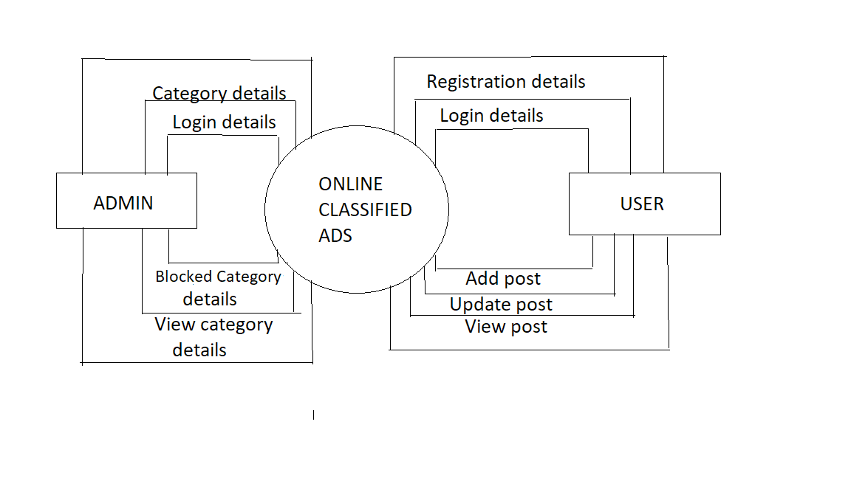

* **‘1’ Level DIAGRAM FOR (customer) :-**

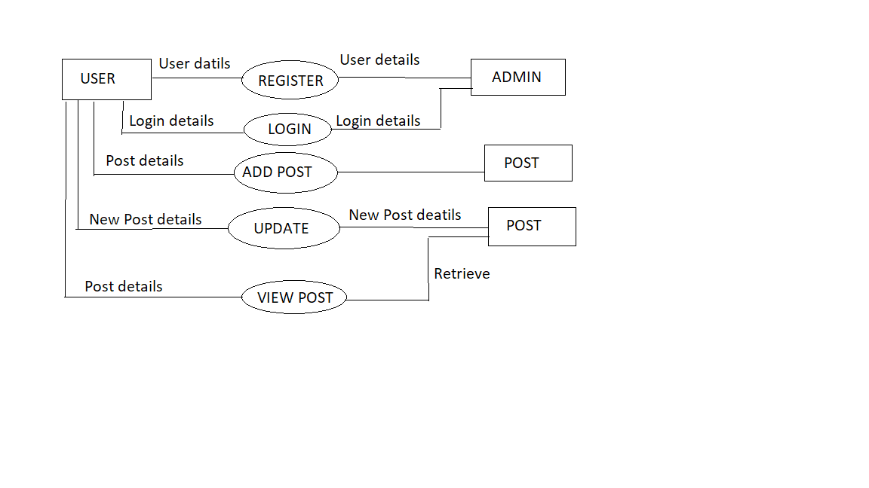

* **‘1’ Level DIAGRAM FOR (Admin) :-**

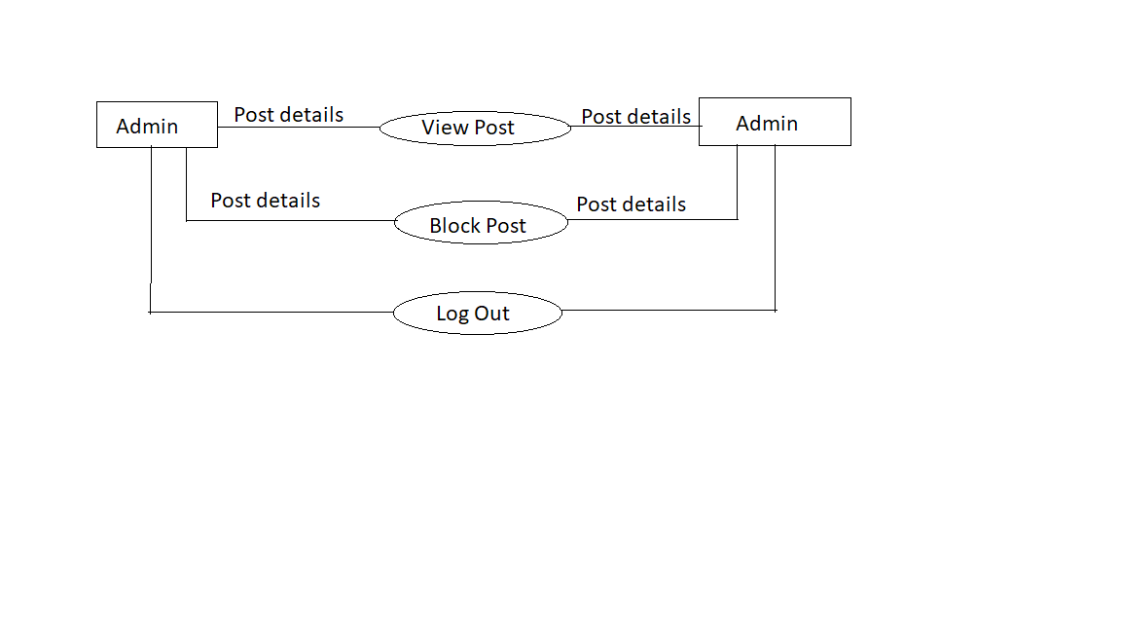

14. Schema/Database Design :-

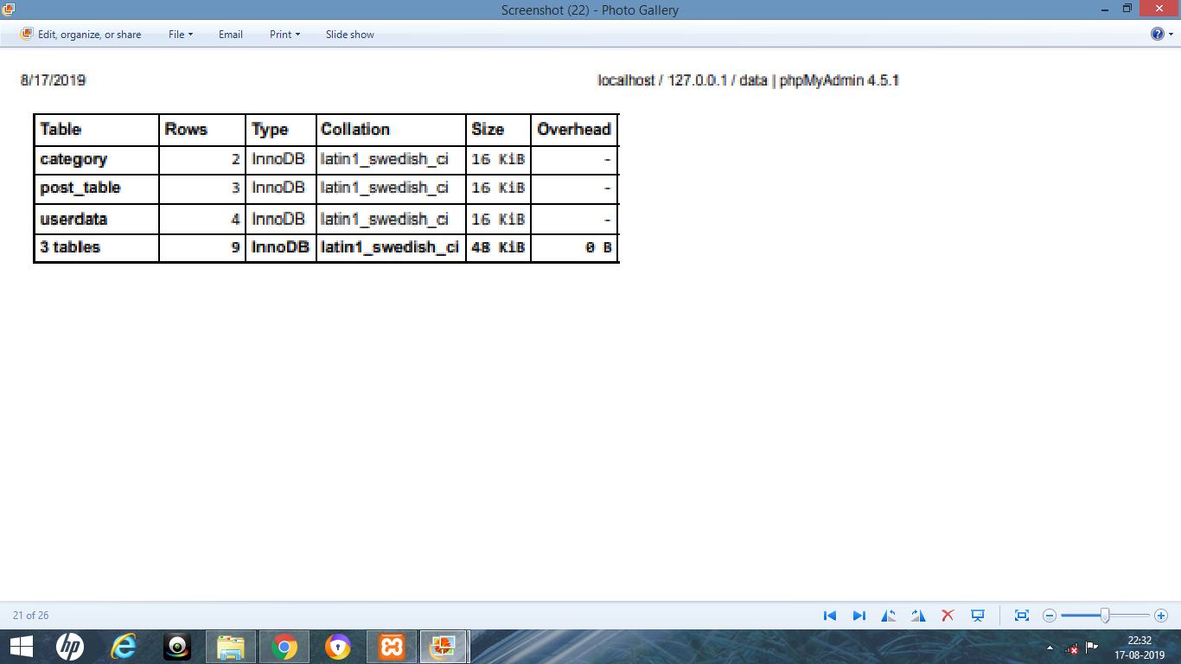

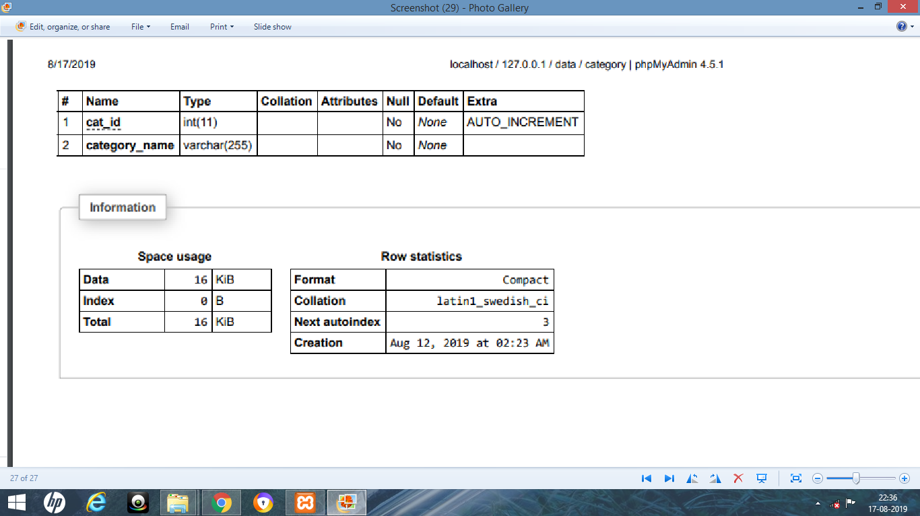

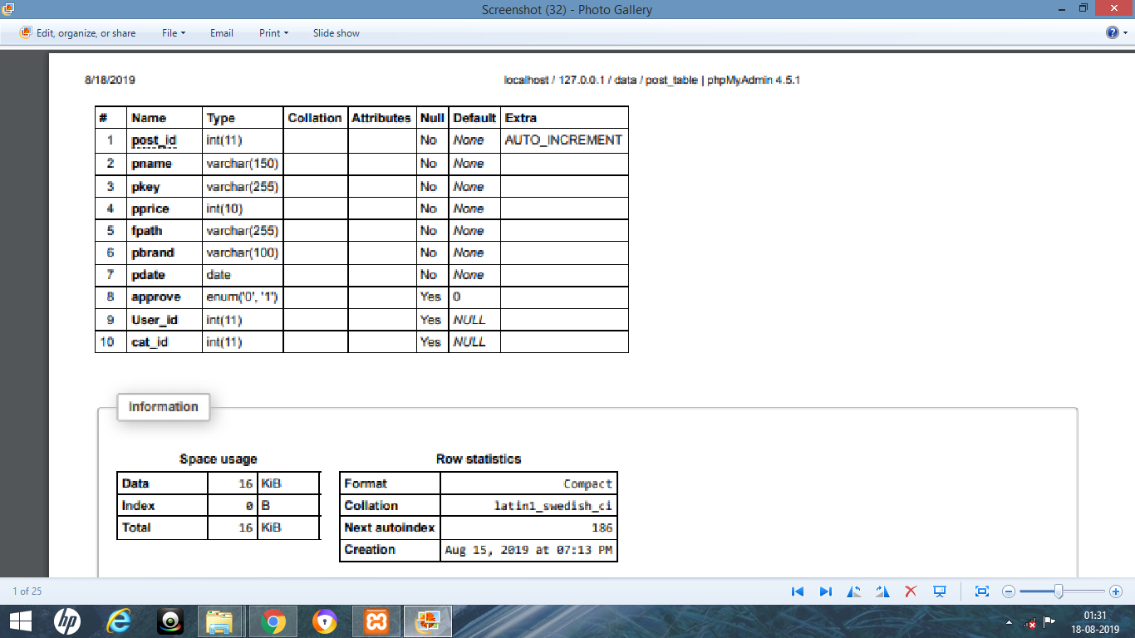

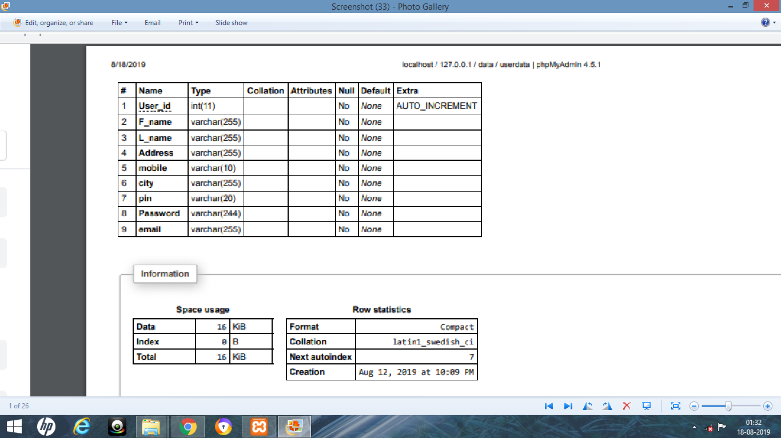

15. User Interface Design:-

* **Home Page :**

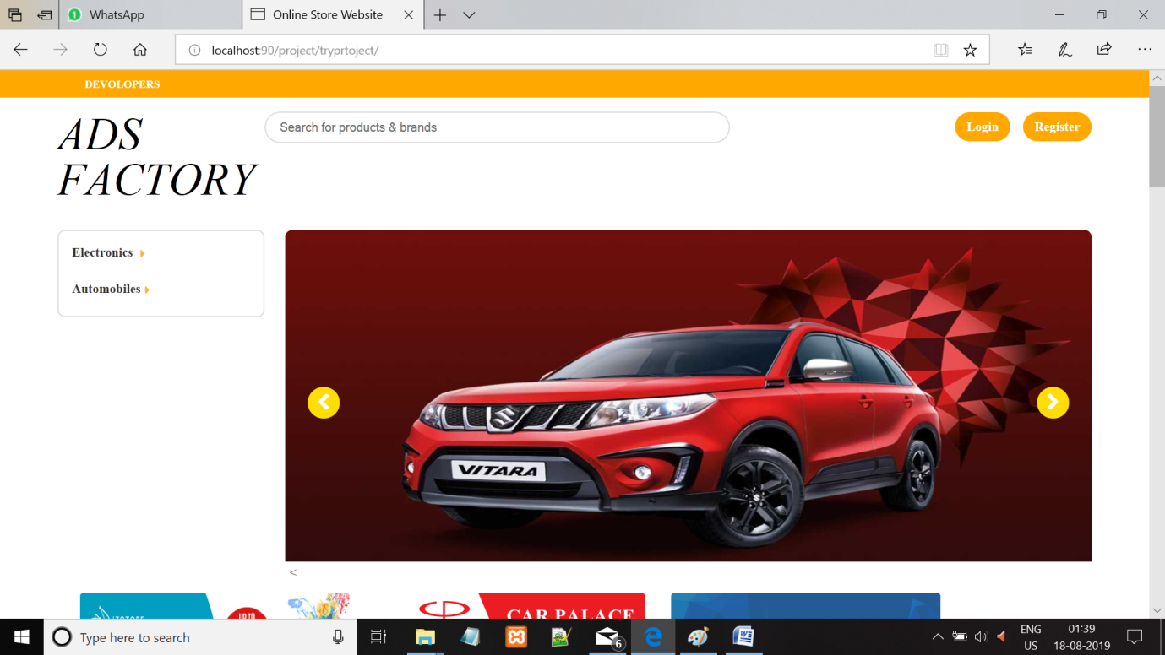

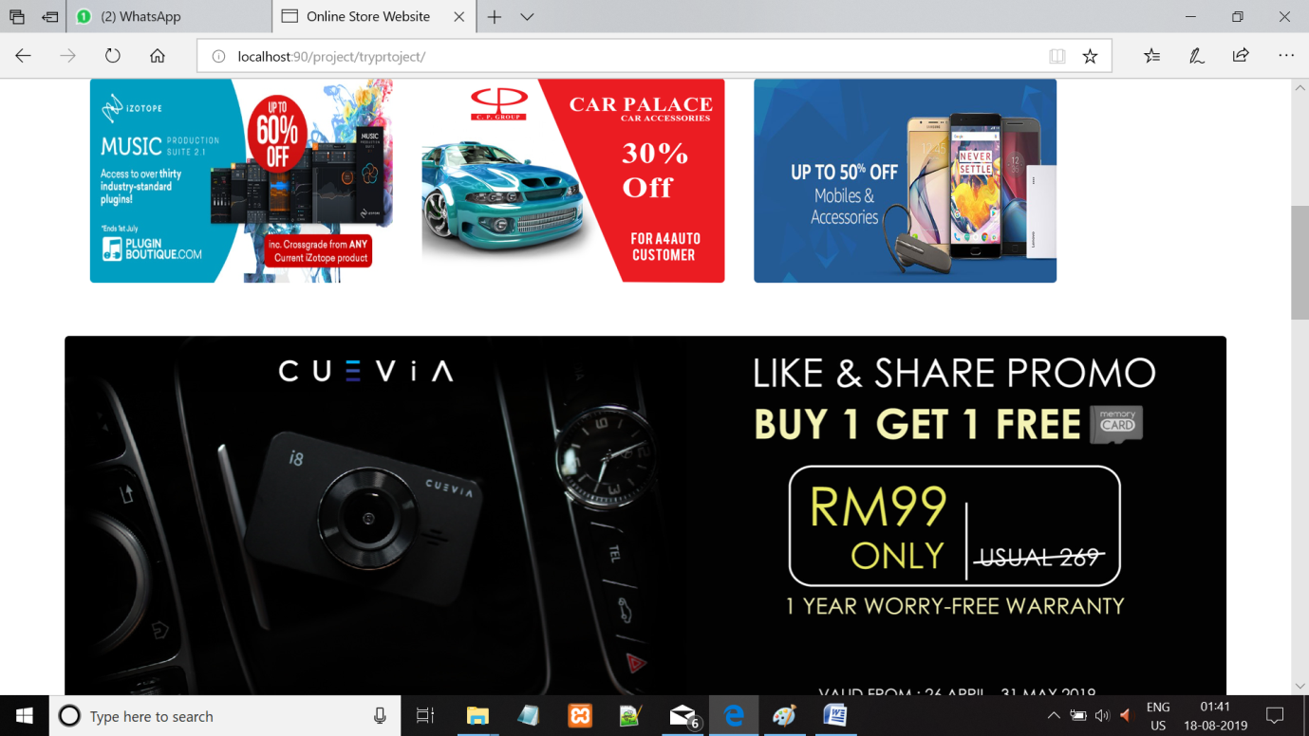

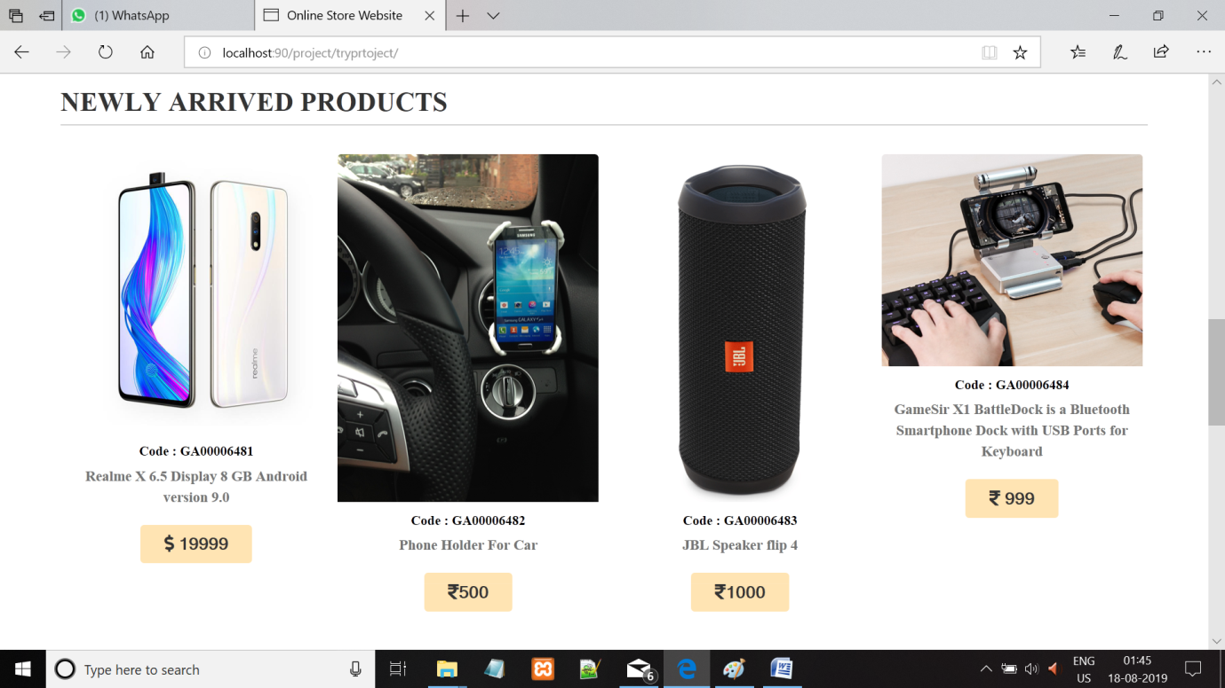

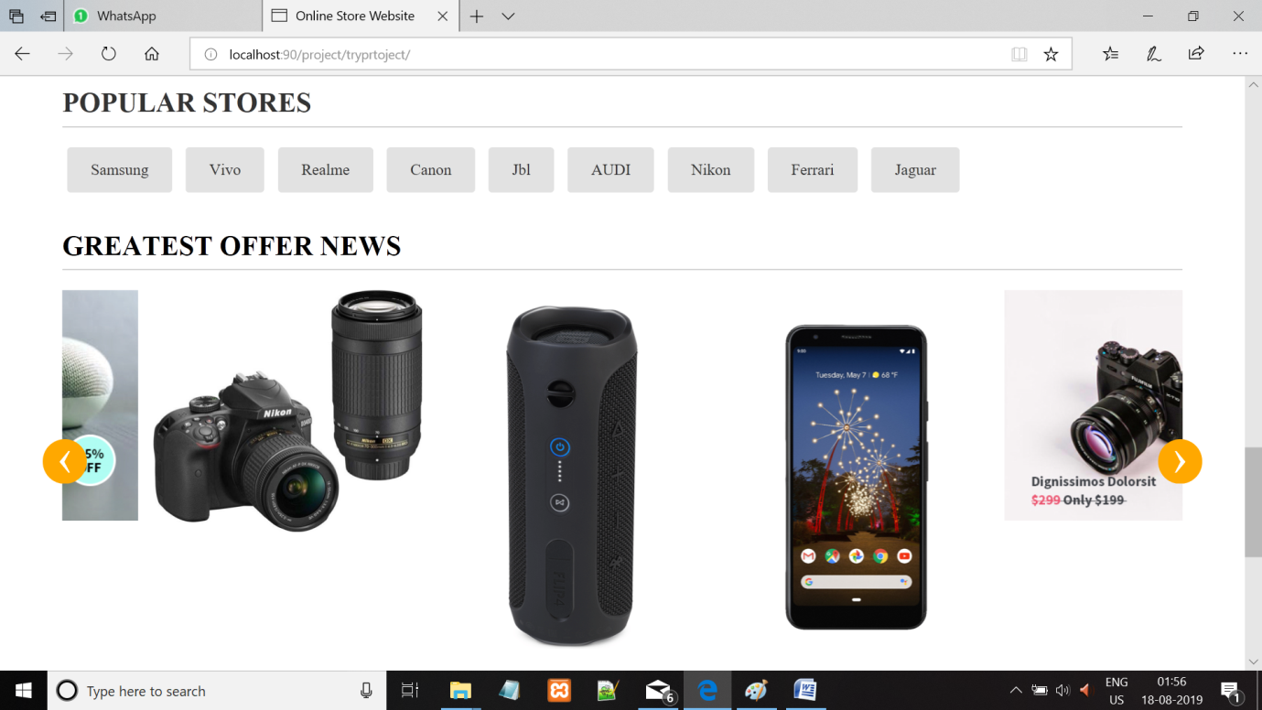

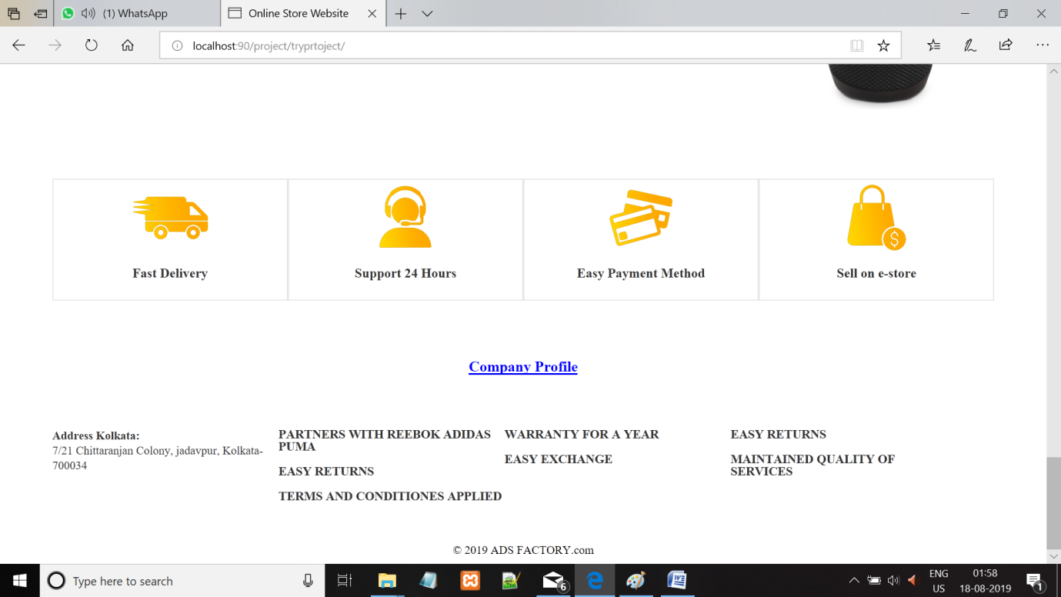

**USER LOGIN PAGE :-**

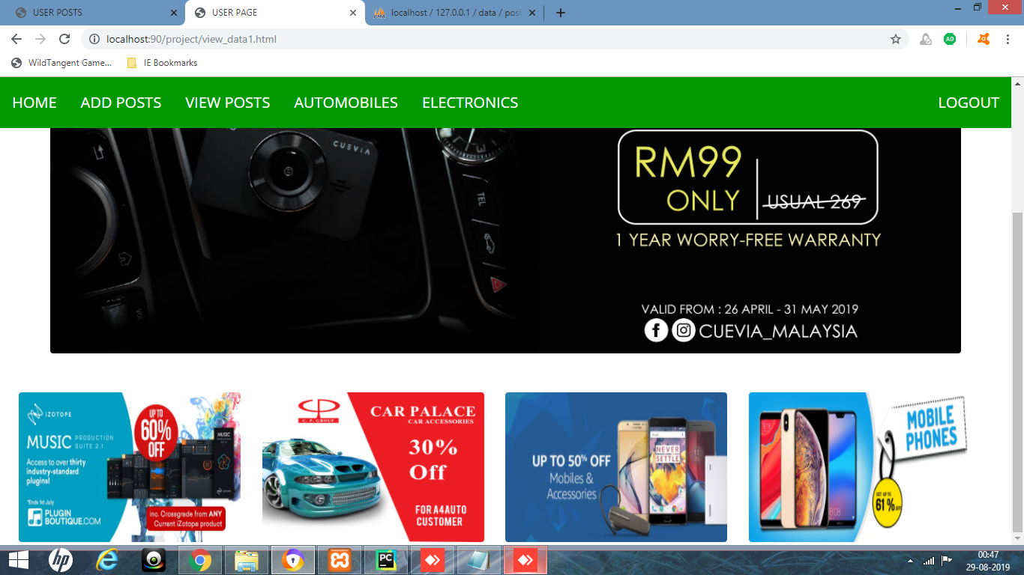

* **Login Page :**

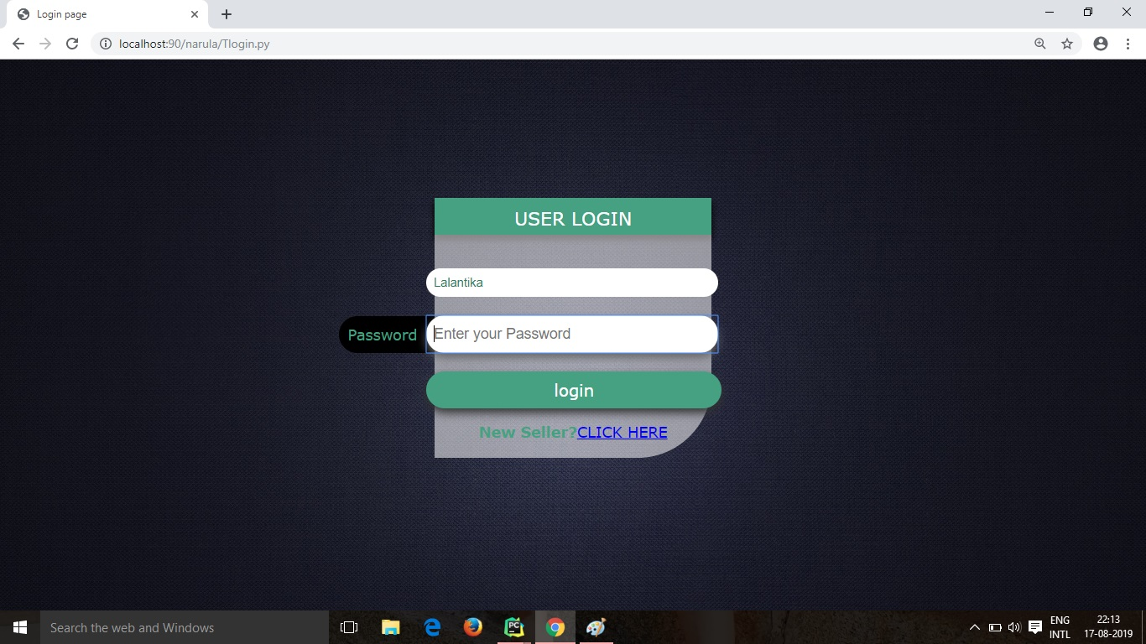

* **Registration Page :**

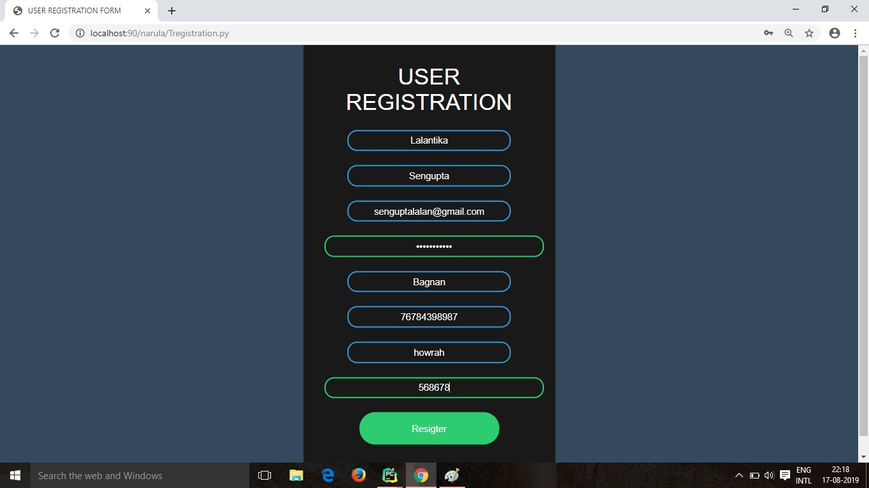

* **Company Profile :**

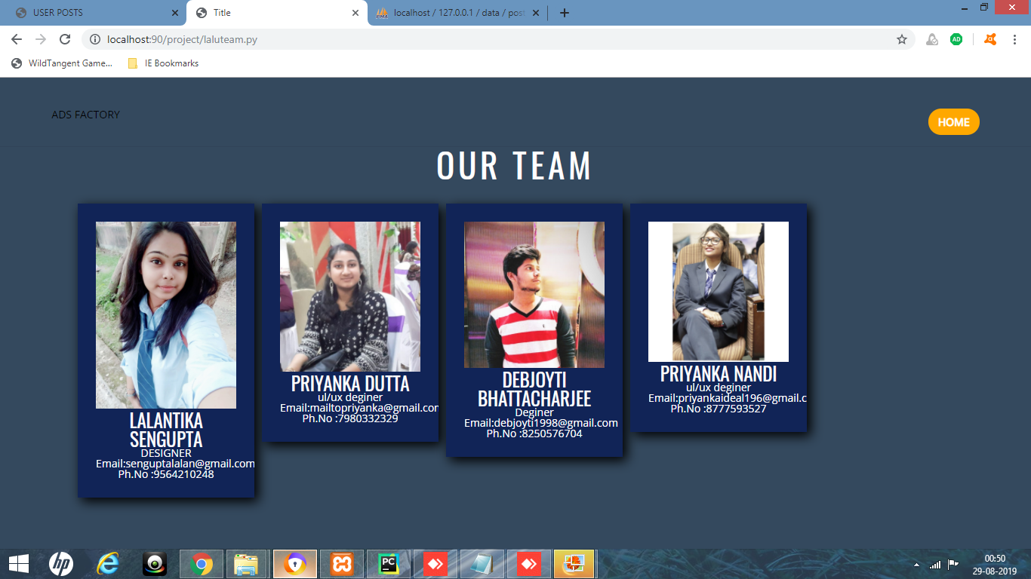

* **insert Items :**

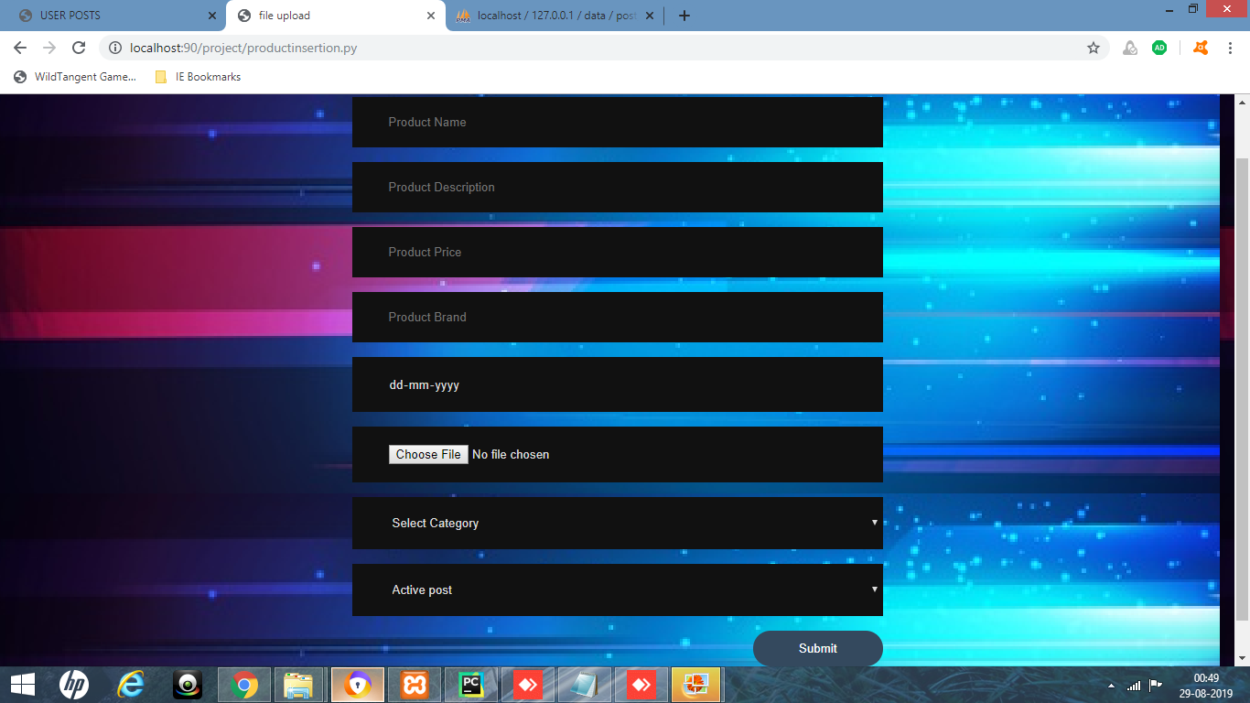

** ELECTRONICS VIEW PAGE :-

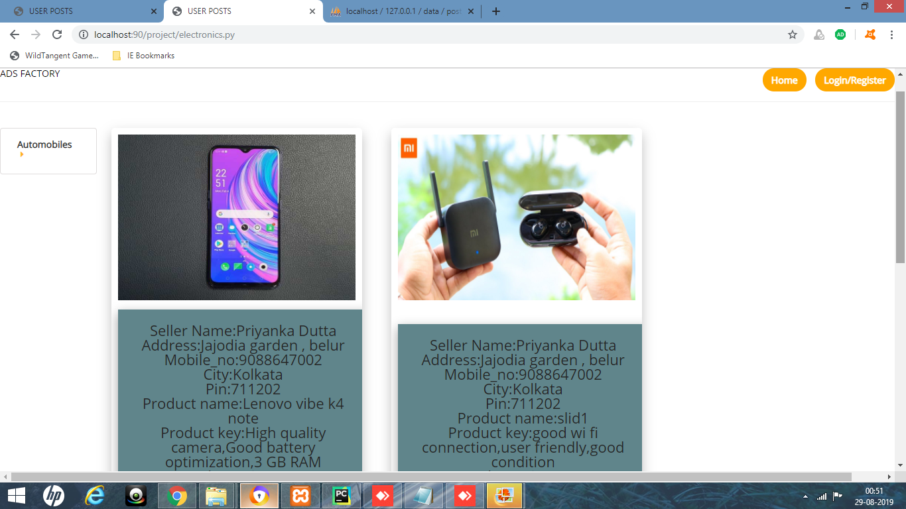

**AUTOMOBILES VIEW PAGE :-

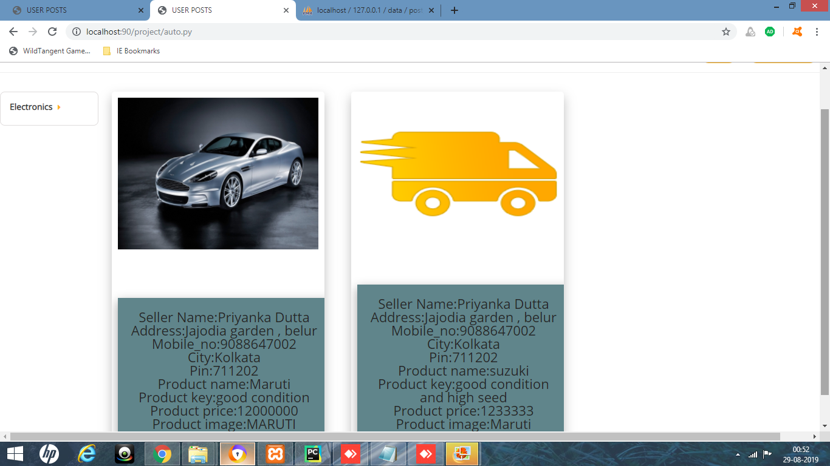

* Admin Panel :-
* **Admin Login :**

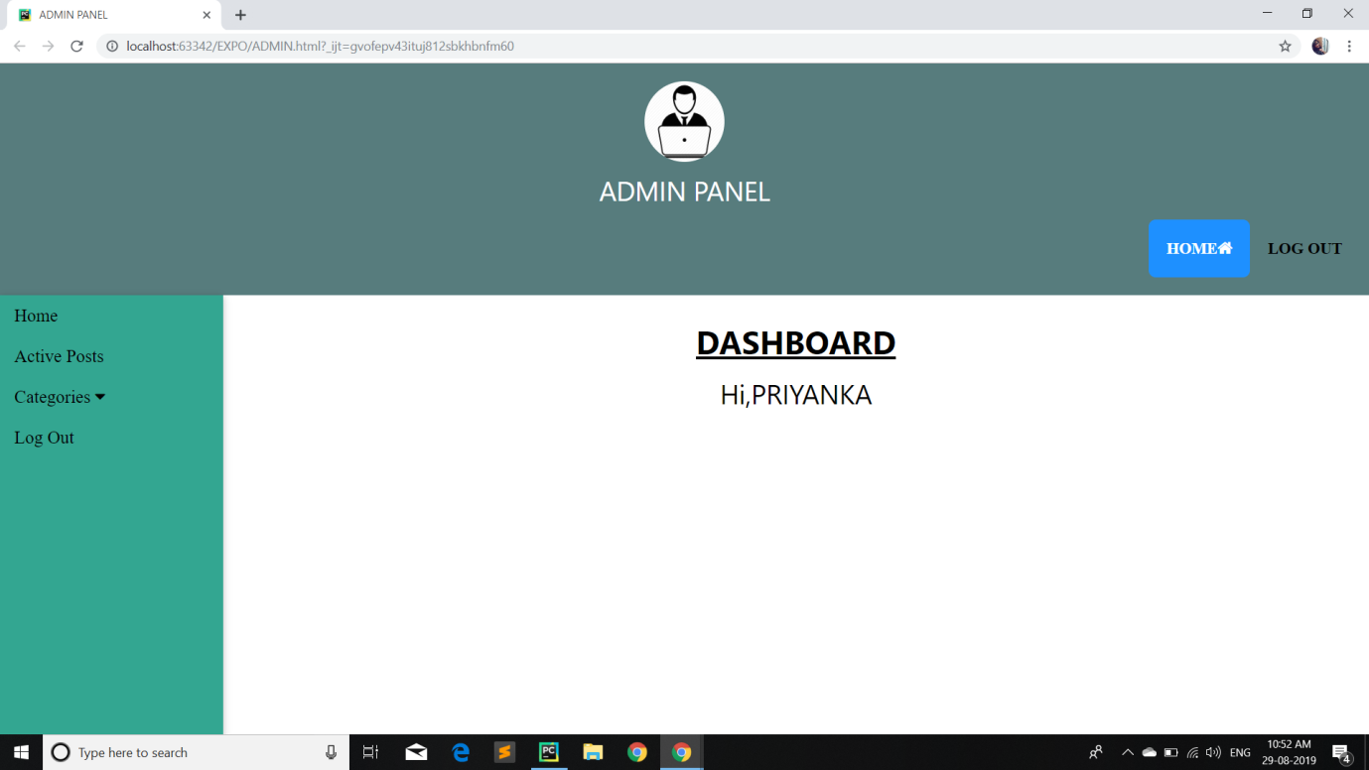

16. Coding:-

* **Home Page:**

<!DOCTYPE html>

<html lang="en">

<head>

<title>Deliccio</title>

<meta charset="utf-8">

<link rel="stylesheet" href="css/reset.css" type="text/css" media="all">

<link rel="stylesheet" href="css/layout.css" type="text/css" media="all">

<link rel="stylesheet" href="css/style.css" type="text/css" media="all">

<link rel="stylesheet" href="css/bootstrap.min1.css" type="text/css" media="all">

<link rel="stylesheet" href="css/style2.css" type="text/css" media="all">

<script src="js/jquery-1.6.js"></script>

<script src="js/cufon-yui.js"></script>

<script src="js/cufon-replace.js"></script>

<script src="js/Forum_400.font.js"></script>

<script src="js/jquery.easing.1.3.js"></script>

<script src="js/tms-0.3.js"></script>

<script src="js/tms_presets.js"></script>

<script src="js/script.js"></script>

<script src="js/atooltip.jquery.js"></script>

</head>

<body id="page1">

<div class="body6">

<div class="body1">

<div class="body5">

<div class="main">

<?phprequire("header.php");?>

<article id="content">

<div class="slider_bg">

<div class="slider">

<ul class="items">

<li><img src="images/img1.jpg" alt="">

<div class="banner"><strong>Italian<span>Fettuccine</span></strong><b>Dish of the Day</b>

<p><span>&nbsp; &nbsp; &nbsp; Developing a Delivarity Design, but working for some time from some time for them, which is the minimum to work as a job.</span></p>

</div>

</li>

<li><img src="images/img2.jpg" alt="">

<div class="banner"><strong>succulent<span>meat</span></strong><b>Dish of the Day</b>

<p><span>&nbsp; &nbsp; &nbsp; Days provide with suitable and delicious hot foods for diabetic patients, but they do not have any work at any time, which acts as nails and narcotics.</span></p>

</div>

</li>

<li><img src="images/img3.jpg" alt="">

<div class="banner"><strong>French-Style<span>Tartlet</span></strong><b>Dish of the Day</b>

<p><span>&nbsp; &nbsp; &nbsp; &nbsp; &nbsp; &nbsp;This is a Delimited Desigining Edison, but working for some time for them, who work for work.</span></p>

</div>

</li>

</ul>

</div>

</div>

<div class="wrap">

<section class="cols">

<div class="box">

<div>

<h2>Welcome <span>to Us!</span></h2>

<figure><img src="images/page1_img1.jpg" alt=""></figure>

<p class="pad_bot1">This Deliccio Template goes with two packages – with PSD source files and without them. PSD source is available for free for the registered members.</p>

</div>

</div>

</section>

<section class="cols pad_left1">

<div class="box">

<div>

<h2>About<span>Us</span></h2>

<figure><img src="images/page1_img2.jpg" alt=""></figure>

<p class="pad_bot1">This is one of free website templates created by TemplateMonster.com team. This website template is optimized for 1024x768 screen res.</p>

</div>

</div>

</section>

<section class="cols pad_left1">

<div class="box">

<div>

<h2>Our<span>Services</span></h2>

<figure><img src="images/page1_img3.jpg" alt=""></figure>

<ul class="list1 pad_bot1">

<li><a href="#">Admin suppliers.</a></li>

<li><a href="#">A free operation has been launched.</a></li>

<li><a href="#">Consistant workers work.</a></li>

<li><a href="#">A small effort.</a></li>

</ul>

</div>

</div>

</section>

</div>

</article>

</div>

</div>

</div>

</div>

<div class="body2">

<div class="main">

<article id="content2">

<div class="wrapper">

<h3>Our<span>Special Dish</span></h3>

<div class="main_portfolio_content">

<div class="col-md-3 col-sm-4 col-xs-6 single_portfolio_text">

<img src="images/p1.jpg" alt="" width="100">

<div class="portfolio_images_overlay text-center">

<h6>Ckicken <br>Kabbab</h6>

<p class="product_price">Rs. 190/-</p>

<a href="order_place.php" class="btn btn-primary">Click here</a>

</div>

</div>

<div class="col-md-3 col-sm-4 col-xs-6 single_portfolio_text">

<img src="images/p2.jpg" alt="">

<div class="portfolio_images_overlay text-center">

<h6>Naan Baad</h6><br>

<p class="product_price">Rs. 50/-</p>

<a href="order_place.php" class="btn btn-primary">Click here</a></div>

</div>

<div class="col-md-3 col-sm-4 col-xs-6 single_portfolio_text">

<img src="images/p3.jpg" alt="">

<div class="portfolio_images_overlay text-center">

<h6>Doi Katla</h6><br>

<p class="product_price">Rs. 110/-</p>

<a href="order_place.php" class="btn btn-primary">Click here</a>

</div>

</div>

<div class="col-md-3 col-sm-4 col-xs-6 single_portfolio_text">

<img src="images/p4.jpg" alt="">

<div class="portfolio_images_overlay text-center">

<h6>Ckicken 65</h6>

<p class="product_price">Rs. 125/-</p>

<a href="order_place.php" class="btn btn-primary">Click here</a>

</div>

</div>

<div class="col-md-3 col-sm-4 col-xs-6 single_portfolio_text">

<img src="images/p5.jpg" alt="" />

<div class="portfolio_images_overlay text-center">

<h6>Tandoori Chicken</h6>

<p class="product_price">Rs. 210/-</p>

<a href="order_place.php" class="btn btn-primary">Click here</a>

</div>

</div>

<div class="col-md-3 col-sm-4 col-xs-6 single_portfolio_text">

<img src="images/p6.jpg" alt="">

<div class="portfolio_images_overlay text-center">

<h6>Paneer Tikka</h6>

<p class="product_price">Rs. 135/-</p>

<a href="order_place.php" class="btn btn-primary">Click here</a>

</div>

</div>

<div class="col-md-3 col-sm-4 col-xs-6 single_portfolio_text">

<img src="images/p7.jpg" alt="">

<div class="portfolio_images_overlay text-center">

<h6>Fish<br> Tandoori</h6>

<p class="product_price">Rs. 220/-</p>

<a href="order_place.php" class="btn btn-primary">Click here</a>

</div>

</div>

<div class="col-md-3 col-sm-4 col-xs-6 single_portfolio_text">

<img src="images/p8.gif" alt="" />

<div class="portfolio_images_overlay text-center">

<h6>Chicken Biriyani</h6>

<p class="product_price">Rs. 155/-</p>

<a href="order_place.php" class="btn btn-primary">Click here</a>

</div>

</div>

</div>

</div>

</article>

</div>

</div>

<?phprequire('footer.php');?>

<script>Cufon.now();</script>

</body>

</html>

* **User Login:-**

**import cgi,cgitb**

**frm=cgi.FieldStorage()**

**msg=frm.getvalue('msg')**

**print''' Content-type:text/html\r\n\r\n**

**<!DOCTYPE html>**

**<html lang="en">**

**<head>**

**<meta charset="UTF-8">**

**<title>Login</title>**

**</head>**

**<body bgcolor= "#faebd7">**

**<center>**

**<h1>User Login</h1>**

**<form name="frm" method="post" action="userlogin.py">**

**<table cellpadding="15">**

**<tr>**

**<td><mark>Email-id</mark></td>**

**<td><input type="mail" name="E_mail" placeholder="enter your email" required></td>**

**</tr>**

**<tr>**

**<td><mark>Password<mark></td>**

**<td><input type="password" name="Password" placeholder="enter your password" required></td>**

**<tr>**

**<td>&nbsp</td>**

**<td>**

**<input type="submit" name="ok"value="login">**

**</td>**

**</tr>**

**</table>**

**</form>**

**'''**

**print '''<form name="frm" method="post" action="user.py">**

**<table cellpadding="15">**

**<tr>**

**<td>&nbsp</td>**

**<td><mark>New seller?</mark></td>**

**<td><input type="submit" name="ok" value="click here"></td>**

**</tr>**

**</table>**

**</form>**

**</center>'''**

**if msg:**

**print msg+"<br>"**

**print '''</body>**

**</html>**

**'''**

* **Admin Login**

**import cgi,cgitb**

**frm=cgi.FieldStorage()**

**msg=frm.getvalue('msg')**

**print''' Content-type:text/html\r\n\r\n**

**<!DOCTYPE html>**

**<html lang="en">**

**<head>**

**<meta charset="UTF-8">**

**<title>Login</title>**

**</head>**

**<body bgcolor= "#faebd7">**

**<center>**

**<h1>User Login</h1>**

**<form name="frm" method="post" action="userlogin.py">**

**<table cellpadding="15">**

**<tr>**

**<td><mark>Email-id</mark></td>**

**<td><input type="mail" name="E_mail" placeholder="enter your email" required></td>**

**</tr>**

**<tr>**

**<td><mark>Password<mark></td>**

**<td><input type="password" name="Password" placeholder="enter your password" required></td>**

**<tr>**

**<td>&nbsp</td>**

**<td>**

**<input type="submit" name="ok"value="login">**

**</td>**

**</tr>**

**</table>**

**</form>**

**'''**

**print '''<form name="frm" method="post" action="user.py">**

**<table cellpadding="15">**

**<tr>**

**<td>&nbsp</td>**

**<td><mark>New seller?</mark></td>**

**<td><input type="submit" name="ok" value="click here"></td>**

**</tr>**

**</table>**

**</form>**

**</center>'''**

**if msg:**

**print msg+"<br>"**

**print '''</body>**

**</html>**

**'''**

* **View All Items Page**
* **Add Items Page**

**import cgi,config**

**cursor = config.db.cursor()**

**frm = cgi.FieldStorage()**

**print ''' Content-type:text/html\r\n\r\n**

**<!doctype html>**

**<html>**

**<head>**

**<meta charset="utf-8">**

**<title>file upload</title>**

**</head>**

**<body>**

**<form name="frm" method="post" action="upload_code.py" enctype="multipart/form-data">**

**<table cellpadding="10">**

**<tr>**

**<td><mark>Product name</mark></td>**

**<td><input type="text" name="pname" ></td>**

**</tr>**

**<tr>**

**<td><mark>pkey</mark></td>**

**<td><input type="text" name="pkey"></td>**

**</tr>**

**<tr>**

**<td><mark>Product Price</mark></td>**

**<td><input type="text" name="pprice"></td>**

**</tr>**

**<tr>**

**<td><mark>category</mark></td>**

**<td colspan="2" align="center">**

**<select name="cat_id">**

**<option value="" selected>select category</option>'''**

**cursor.execute('SELECT * FROM category')**

**result = cursor.fetchall()**

**for rec in result:**

**print '''<option value="{}">{}</option>'''.format(rec[0], rec[1])**

**print ''' </select>**

**</td>**

**</tr>**

**<tr>**

**<td><mark>Product Brand</mark></td>**

**<td><input type="text" name="pbrand"></td>**

**</tr>**

**<tr>**

**<td><mark>Approval</mark></td>**

**<td><input type="text" name="approve"></td>**

**</tr>**

**<tr>**

**<td><mark>pdate</mark></td>**

**<td><input type="date" name="pdate"></td>**

**</tr>**

**<tr>**

**<td><mark>pimage</mark></td>**

**<td><input type="file" name="file"></td>**

**</tr>**

**<tr>**

**<td></td>**

**<td><input type="submit" name="Insert"></td>**

**</tr>**

**</table>**

**</form>'''**

**if frm.getvalue('msg'):**

**print frm.getvalue('msg')**

**print'''</body>**

**</html>'''**

* **View Team:-**

**print '''content-type:text/html\r\n\r\n**

**<!DOCTYPE html>**

**<html lang="en">**

**<head>**

**<meta charset="UTF-8">**

**<title>Title</title>**

**<link rel="stylesheet" href="style4.css">**

**</head>**

**<body>**

**<div class="wrapper">**

**<div class="section-header">**

**<h1 class="heading">Our Team</h1>**

**</div>**

**<div class="team-member">**

**<img src="titir.jpg" alt="">**

**<h3><em>Lalantika Sengupta</em></h3>**

**<p><em>DESIGNER</em></p>**

**<p><b>Email:</b>senguptalalan@gmail.com <b>Ph.No :</b>9564210248</P>**

**</div>**

**<div class="team-member">**

**<img src="IMG_20190102_173353_658.jpg" alt="">**

**<h3><em>Priyanka Dutta</em></h3>**

**<p>ul/ux deginer</p>**

**<p><b>Email:</b>mailtopriyanka@gmail.com <b>Ph.No :</b>7980332329</p>**

**</div>**

**<div class="team-member">**

**<img src="IMG_20190102_173353_658.jpg" alt="">**

**<h3><em>Debjoyti Bhattacharjee</em></h3>**

**<p>ul/ux deginer</p>**

**<p><b>Email:</b>debjoyti1998@gmail.com <b>Ph.No :</b>8250576704</p>**

**</div>**

**<div class="team-member">**

**<img src="IMG_20190102_173353_658.jpg" alt="">**

**<h3><em>Priyanka Nandi</em></h3>**

**<p>ul/ux deginer</p>**

**<p><b>Email:</b>priyankaideal196@gmail.com <b>Ph.No :</b>8777593527</p>**

**<p>**

**<i class="fa fa-facebook"></i>**

**<i class="fa fa-instragram"></i>**

**</p>**

**</div>**

**</div>**

**</body>**

**</html>'''**

USER Login Page:-

<!DOCTYPE html>

<html>

<head>

<title>USER PAGE</title>

<style>

.head1 {

font-size:40px;

color:#009900;

font-weight:bold;

}

.head2 {

font-size:17px;

margin-left:10px;

margin-bottom:15px;

}

body {

margin: 0 auto;

background-position:center;

background-size: contain;

}

.menu {

position: sticky;

top: 0;

background-color: #009900;

padding:10px 0px 10px 0px;

color:white;

margin: 0 auto;

overflow: hidden;

}

.menu a {

float: left;

color: white;

text-align: center;

padding: 14px 16px;

text-decoration: none;

font-size: 20px;

}

.menu-log {

right: auto;

float: right;

}

footer {

width: 100%;

bottom: 0px;

background-color: #000;

color: #fff;

position: absolute;

padding-top:20px;

padding-bottom:50px;

text-align:center;

font-size:30px;

font-weight:bold;

}

.viewed-product{

width: 280px;

height: 500px;

display: inline-block;

margin-left: 25px;

margin-top: 15px;

border-radius: 4px;

overflow: hidden;

}

.viewed-product img{

width: 100%;

height: 270px;

}

</style>

</head>

<body>

<!-- Header Section -->

<header>

<div class="head1">ADS FACTORY</div>

<div class="head2">Now sellings are much easy</div>

</header>

<!-- Menu Navigation Bar -->

<div class="menu">

<a href="http://localhost:63342/project/tryprtoject/index.html?_ijt=5f8q0ensaedrh5j69alnun53p5">HOME</a>

<a href="http://localhost:90/project/productinsertion.py">ADD POSTS</a>

<a href="http://localhost:90/project/present_post.py">VIEW POSTS</a>

<div class="menu-log">

<a href="http://localhost:90/project/log_out.py">LOGOUT</a>

</div>

</div>

<!-- Body section -->

<div class = "viewed-product">

<a href="#">

<img height="250px" src="images1/product8.jpg">

</a>

<details>

<summary><big>product details</big></summary>

<p>MODEL NUM- 2345</p>

<p>PRODUCT NAME - NIKON 200D</p>

</details>

<p>reached to people :<meter optimum="30" high="80" max="100" value="85">85%</meter></p>

</div>

<div class="viewed-product">

<a href="#">

<img src="images1/product5.jpg">

</a>

<details>

<summary><big>product details</big></summary>

<p>MODEL NUM- 2358</p>

<p>PRODUCT NAME - Realme X 6.5 Display 8 GB Android version 9.0</p>

</details>

<p>reached to people :<meter optimum="35" high="75" max="100" value="80">80%</meter></p>

</div>

<div class="viewed-product">

<a href="#">

<img src="images1/product2.jpg">

</a>

<details>

<summary><big>product details</big></summary>

<p>MODEL NUM- 2345</p>

<p>PRODUCT NAME - GOOGLE PIXEL 6.6 Display 8 GB Android version 9.0</p>

</details>

<p>reached to people :<meter optimum="40" high="60" max="100" value="70">70%</meter></p>

</div>

<div class="viewed-product">

<a href="#">

<img src="images1/product3.jpg">

</a>

<details>

<summary><big>product details</big></summary>

<p>MODEL NUM- 2345</p>

<p>PRODUCT NAME - GameSir X1 BattleDock is a Bluetooth Smartphone Dock with USB Ports for Keyboard</p>

</details>

<p>reached to people :<meter optimum="30" high="80" max="100" value="50">50%</meter></p>

</div>

</body>

</html>

**17. Testing :-**

## Team Interaction

The following describes the level of team interaction necessary to have a successful product.

* The Test Team will work closely with the Development Team to achieve a high quality design and user interface specifications based on customer requirements. The Test Team is responsible for visualizing test cases and raising quality issues and concerns during meetings to address issues early enough in the development cycle.
* The Test Team will work closely with Development Team to determine whether or not the application meets standards for completeness. If an area is not acceptable for testing, the code complete date will be pushed out, giving the developers additional time to stabilize the area.
* Since the application interacts with a back-end system component, the Test Team will need to include a plan for integration testing. Integration testing must be executed successfully prior to system testing.

# est Objective

The objective our test plan is to find and report as many bugs as possible to improve the integrity of our program. Although exhaustive testing is not possible, we will exercise a broad range of tests to achieve our goal. We will be testing a Binary Search Tree Application utilizing a pre-order traversal format. There will be eight key functions used to manage our application: load, store, clear, search, insert, delete, list in ascending order, and list in descending order. Our user interface to utilize these functions is designed to be user-friendly and provide easy manipulation of the tree. The application will only be used as a demonstration tool, but we would like to ensure that it could be run from a variety of platforms with little impact on performance or usability.

* **Process Overview**

The following represents the overall flow of the testing process:

Identify the requirements to be tested. All test cases shall be derived using the current Program Specification.

1. Identify which particular test(s) will be used to test each module.
2. Review the test data and test cases to ensure that the unit has been thoroughly verified and that the test data and test cases are adequate to verify proper operation of the unit.
3. Identify the expected results for each test.
4. Document the test case configuration, test data, and expected results.
5. Perform the test(s).
6. Document the test data, test cases, and test configuration used during the testing process. This information shall be submitted via the Unit/System Test Report .
7. Successful unit testing is required before the unit is eligible for component integration/system testing.
8. Unsuccessful testing requires a Bug Report Form to be generated. This document shall describe the test case, the problem encountered, its possible cause, and the sequence of events that led to the problem. It shall be used as a basis for later technical analysis.
9. Test documents and reports shall be submitted. Any specifications to be reviewed, revised, or updated shall be handled immediately.

# Testing Process

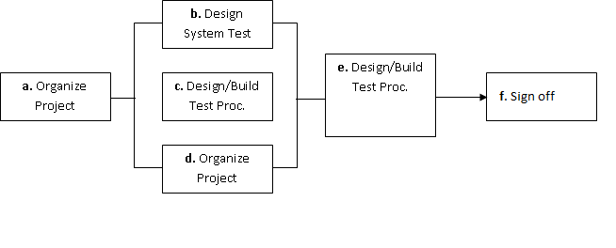

The diagram above outlines the Test Process approach that will be followed.

**a.rganize Project** involves creating a System Test Plan, Schedule & Test Approach, and assigning responsibilities.

**b.Design/Build System Test** involves identifying Test Cycles, Test Cases, Entrance & Exit Criteria, Expected Results, etc. In general, test conditions/expected results will be identified by the Test Team in conjunction with the Development Team. The Test Team will then identify Test Cases and the Data required. The Test conditions are derived from the Program Specifications Document.

**c.Design/Build Test Procedures** includes setting up procedures such as Error Management systems and Status reporting.

**d.Build Test Environment** includes requesting/building hardware, software and data set-ups.

**e.Execute System Tests –** The tests identified in the Design/Build Test Procedures will be executed. All results will be documented and Bug Report Forms filled out and given to the Development Team as necessary.

**f.Signoff** - Signoff happens when all pre-defined exit criteria have been achieved.

# Testing Strategy

The following outlines the types of testing that will be done for unit, integration, and system testing. While it includes what will be tested, the specific use cases that determine how the testing is done will be detailed in the Test Design Document. The test cases that will be used for designing use cases is shown in Figure 2.1 and onwards.

* **Test Cases:**

|  |  |  |  |
| --- | --- | --- | --- |
| **Tested By:** | | Debjoyti Bhattacharjee | |
| **Test Type** | | Unit Testing | |
| **Test Case Number** | | 1 | |
| **Test Case Name** | | User Identification | |
| **Test Case Description** | | The user should enter his/ her accurate userid and password so that he/she can able to go for the further options. The test case will check the application for the same since a user can only login with the correct userid , password. | |
| **Item(s) to be tested** | | | |
| 1 | Verification of the userid and password with the record in the database. | | |
| **Specifications** | | | |
| **Input** | | | **Expected**  **Output/Result** |
| 1. Correct User id and password 2. Incorrect Id or Password | | | 1. Successful login 2. Failure Message |

|  |  |  |  |
| --- | --- | --- | --- |
| **Tested By:** | | Lalantika Sengupta | |
| **Test Type** | | Unit Testing | |
| **Test Case Number** | | 2 | |
| **Test Case Name** | | Add User Details | |
| **Test Case Description** | | The User must add details. | |
| **Item(s) to be tested** | | | |
| 1 | Check whether all the mandatory fields are filled up. | | |
| **Specifications** | | | |
| **Input** | | | **Expected**  **Output/Result** |
| 1. Trying to submit without filling the mandatory fields. 2. Check the valid data for all form fields. | | | 1. A message asks the user to fill the form correctly 2. Return an error message. |

|  |  |  |  |
| --- | --- | --- | --- |
| **Tested By:** | | Priyanka Dutta | |
| **Test Type** | | Unit Testing | |
| **Test Case Number** | | 2 | |
| **Test Case Name** | | Add User Details | |
| **Test Case Description** | | The User must add details. | |
| **Item(s) to be tested** | | | |
| 1 | Check whether all the mandatory fields are filled up. | | |
| **Specifications** | | | |
| **Input** | | | **Expected**  **Output/Result** |
| 1. Trying to submit without filling the mandatory fields. 2. Check the valid data for all form fields. | | | 1. A message asks the user to fill the form correctly 2. Return an error message. |

|  |  |  |  |
| --- | --- | --- | --- |
| **Tested By:** | | Priyanka Nandi | |
| **Test Type** | | Unit Testing | |
| **Test Case Number** | | 2 | |
| **Test Case Name** | | Add User Details | |
| **Test Case Description** | | The User must add details. | |
| **Item(s) to be tested** | | | |
| 1 | Check whether all the mandatory fields are filled up. | | |
| **Specifications** | | | |
| **Input** | | | **Expected**  **Output/Result** |
| 1. Trying to submit without filling the mandatory fields. 2. Check the valid data for all form fields. | | | 1. A message asks the user to fill the form correctly 2. Return an error message. |

## Unit Testing :-

Unit Testing is done at the source or code level for language-specific programming errors such as bad syntax, logic errors, or to test particular functions or code modules. The unit test cases shall be designed to test the validity of the programs correctness.

### White Box Testing

In white box testing, the UI is bypassed. Inputs and outputs are tested directly at the code level and the results are compared against specifications. This form of testing ignores the function of the program under test and will focus only on its code and the structure of that code. Test case designers shall generate cases that not only cause each condition to take on all possible values at least once, but that cause each such condition to be executed at least once. To ensure this happens, we will be applying Branch Testing. Because the functionality of the program is relatively simple, this method will be feasible to apply.

Each function of the binary tree repository is executed independently; therefore, a program flow for each function has been derived from the code.

* **Black Box Testing**

Black box testing typically involves running through every possible input to verify that it results in the right outputs using the software as an end-user would. We have decided to perform Equivalence Partitioning and Boundary Value Analysis testing on our application.

## System Testing :-

The goals of system testing are to detect faults that can only be exposed by testing the entire integrated system or some major part of it. Generally, system testing is mainly concerned with areas such as performance, security, validation, load/stress, and configuration sensitivity. But in our case well focus only on function validation and performance. And in both cases we will use the black-box method of testing.

18. System Security measures (Implementation of security for the project developed) :-

* Only authorized users are allowed.

Without signing in users are not allowed to go an intermediate page by typing an URL. For all such efforts, users will be redirected to the home page

19. Database/Data security :-

* Database is present in remote machine.
* PHP’s default securities are applied.

20. Creation of User profiles and access rights :-

* The admin must create users manually
* The admin can create more admins

21. Cost Estimation of the Project along with Cost Estimation Model :-

Analogous estimate of effort or cost

Used for Early Estimate or Individual Activity Estimate

Sample example shown below is for two major deliverables of a software project. You use a previous project as a benchmark for analogous estimation. Using your experience you will estimate a multiplier.

* **Multipliers:**

1. Prototyping: 0.75.
2. Testing: 0.5
3. Deployment: 0.5

Finally, if you want to convert to cost, you would use current rates for the resource.

|  |  |  |  |  |  |  |
| --- | --- | --- | --- | --- | --- | --- |
| **WBS ID** | **Previous**  **Similar Project**  **Activity** | **Previous**  **Effort** | **Current**  **Project**  **Estimate** | **Multiplier** | **Effort**  **(Previous Effort * 0.75)** | **Cost**  **(Rs. 500/hr.)** |
| 1 | Prototyping | 40 Work-Hours | Prototyping | 0.75 | 30 Work-hours | Rs. 15000/- |
| 2 | Testing | 20 Work-Hours | Testing | 0.50 | 10 Work-Hours | Rs. 5000/- |
| **Total** |  |  |  |  | **40 Work- Hours** | **Rs. 20000/-** |

Note: Effort is also called Size and unit of estimation is called either Work-Hour, person-hours.

22. Future scope and further enhancement of the Project :-

Online Classified Ads has lot of enhancement options. LikeEmail order confirmation, Mobile SMS send to confirmed order, online sell, category wise divided products and going market to sell Getaway.

23. Bibliography :-

1. Roger S. Pressman. Software Engineering: A Practioner's Approach (Sixth Edition, International Edition). McGraw-Hill, 2005.
2. Ian Sommerville. Software Engineering (Seventh Edition). Addison-Wesley, 2004.
3. Frederick P. Brooks. The Mythical Man-Month: Essays on Software Engineering, Anniversary Edition. Addison-Wesley Pub Co; 1st edition (August 2, 1995).
4. [PHYTHON and MySQL for Beginners](http://www.amazon.com/PHP-MySQL-Beginners-Mark-Lassoff/dp/0990402010/ref=zg_bs_295223_4)by Mark A Lassoff
5. Database System Concepts by [Abraham Silberschatz](http://www.goodreads.com/author/show/47996.Abraham_Silberschatz), [Henry F. Korth](http://www.goodreads.com/author/show/93497.Henry_F_Korth), [S. Sudarshan](http://www.goodreads.com/author/show/93498.S_Sudarshan)
6. Database System, written by Connolly & Begg
7. HTML BY [Davinder Singh Minhas](http://www.amazon.in/s/277-4669198-3764508?_encoding=UTF8&field-author=Davinder%20Singh%20Minhas&search-alias=stripbooks)
8. HTML and CSS: Design and Build Websites, Author: [Jon Duckett](http://www.flipkart.com/author/jon-duckett).

24. Appendix :-

* **DFD conventions, guidelines, and common errors**

Although DFDs are simple to understand and draw, students and practitioners alike encounter similar types of problems while modelling software problems using DFDs. While learning from experience is powerful thing, it is an expensive pedagogical technique in the business world. It is therefore helpful to understand the different types of mistakes that users usually make while constructing the DFD model of systems.

**• Many beginners commit the mistake of drawing more than one bubble in the context diagram. A context diagram should depict the system as a single bubble.**

• **Many beginners have external entities appearing at all levels of DFDs. All external entities interacting with the system should be represented only in the context diagram. The external entities should not appear at other levels of the DFD.**

• **Many beginners leave different levels of DFD unbalanced.**

• A common mistake committed by many beginners while developing a DFD model is attempting to represent control information in a DFD. It is important to realize that a DFD is the data flow representation of a system, and it does not represent control information. For an example mistake of this kind:

o Consider the following example. A book can be searched in the library catalog by inputting its name. If the book is available in the library, then the details of the book are displayed. If the book is not listed in the catalog, then an error message is generated. While generating the DFD model for this simple problem, many beginners commit the mistake of drawing an arrow (as shown in fig. 1) to indicate the error function is invoked after the search book. But, this is a control information and should not be shown on the DFD.